Requirements/Design Specification

**Divisions Don’t Charge Admin**

**GH 291 – CR 13941**

Revision History

|  |  |  |  |
| --- | --- | --- | --- |
| **Date** | **Revision** | **Description** | **Author** |
| 4/29/2015 | 1.0 | Initial Version with Requirements | Roger Behm |
|  |  |  |  |
|  |  |  |  |
|  |  |  |  |
|  |  |  |  |

The information furnished herein by Republic Services Inc. is proprietary and confidential to Republic Services Inc. personnel and is not to be duplicated, published, or disclosed to any third party in whole or in part without permission from Republic Services, Inc.

© Copyright 2012, Republic Services Inc. - All rights reserved.

Table of contents

1 Business Requirements/Owner – Brittany Smith 6

2 Assumptions 6

3 Design 7

4 InfoPro/TIBCO/BI Impacts 7

5 Report Changes 7

6 Appendix 7

# Business Requirements/Owner – Brittany Smith

For the divisions that do not charge Admin fees for New/New - the box is checked and the header shows Admin fee yes. The value is $0 so the Finalized CSA shows No Admin fee. However the auto upload into InfoPro is tagging the Admin fee as Yes.

The issue is the Division charges an Admin fee, but it is $0. So, in Capture the Admin fees show YES and the box is selected. The Monthly summary shows admin fee of $0.

The Customer Facing CSA shows notes that they are EXEMPT from Admin Fees - Which is not the case. They are charged Admin Fees, but that Divisions charge for Admin fees is $0.

Also, do not allow admin box to be checked when admin fee = 0 in divfeerate table

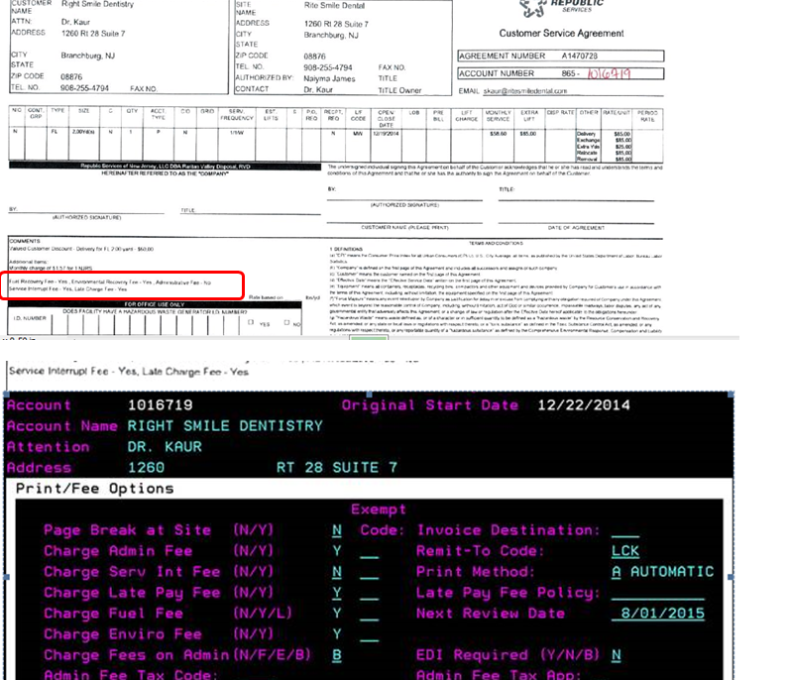

# Assumptions

NA

# Design

The root of this problem is the menu attribute 'inforProDivision_quote' not containing every infoPro division. To return the correct value change the call to use the infoPro Display Only number that is automatically generated. the new filter is:

divisionNumber = $division_quote AND infopro_div_nbr = $infoProNumberDisplayOnly_quote

Also gray out or hid checkbox, defaulted to unchecked - if $0 fees.   
Compensation will add variable to not deduct for $0 fees.

# InfoPro/TIBCO/BI Impacts

No new variable should be needed and no existing variables should be repurposed for any of the above changes.

# Report Changes

NA

# Appendix